# Apply filters to SQL queries

## Project description

SQL has made it possible for me as an entry level cybersecurity analyst to use the several queries to retrieve information from several databases holding different kinds of information. Some of the databases include vulnerability databases, login attempts database, machine database, OS database that are being used across an organization. Thus, this project aims to demonstrate several use cases of SQL in a security environment.

## Retrieve after hours failed login attempts

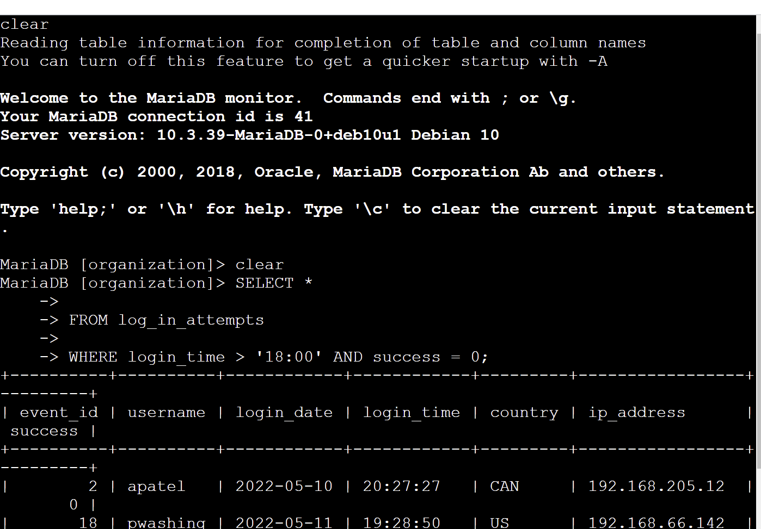

## Retrieve login attempts on specific dates

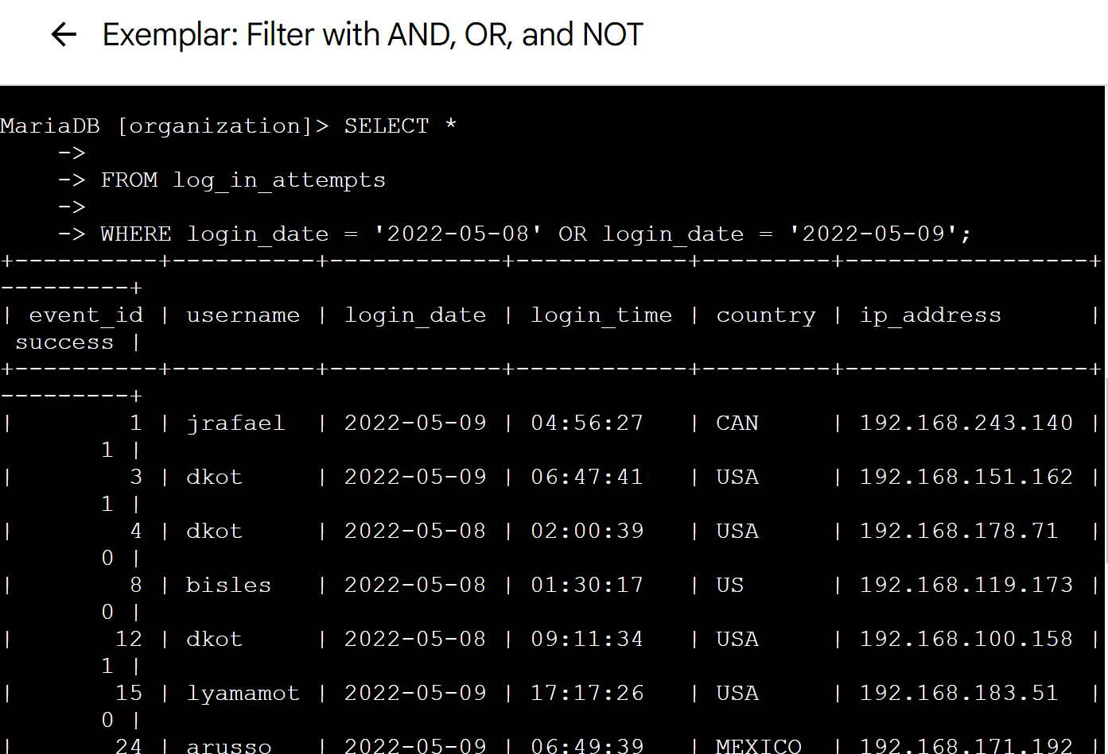

## Retrieve login attempts outside of Mexico

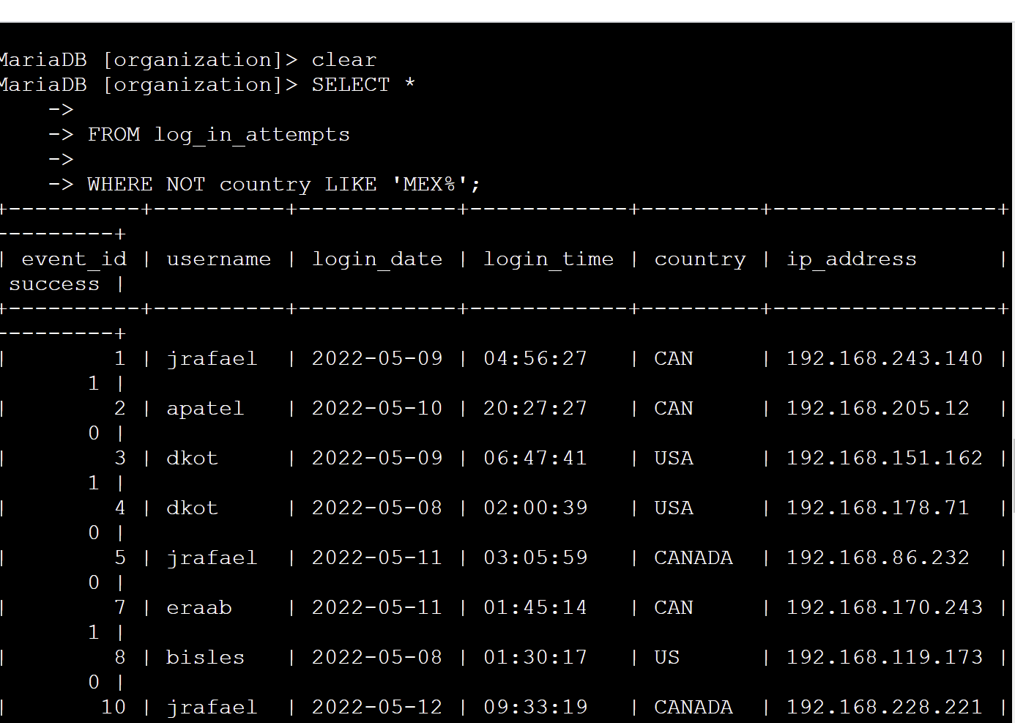

## Retrieve employees in Marketing

SELECT *

FROM employees

WHERE department = ‘Marketing’ AND office LIKE ‘East%’;

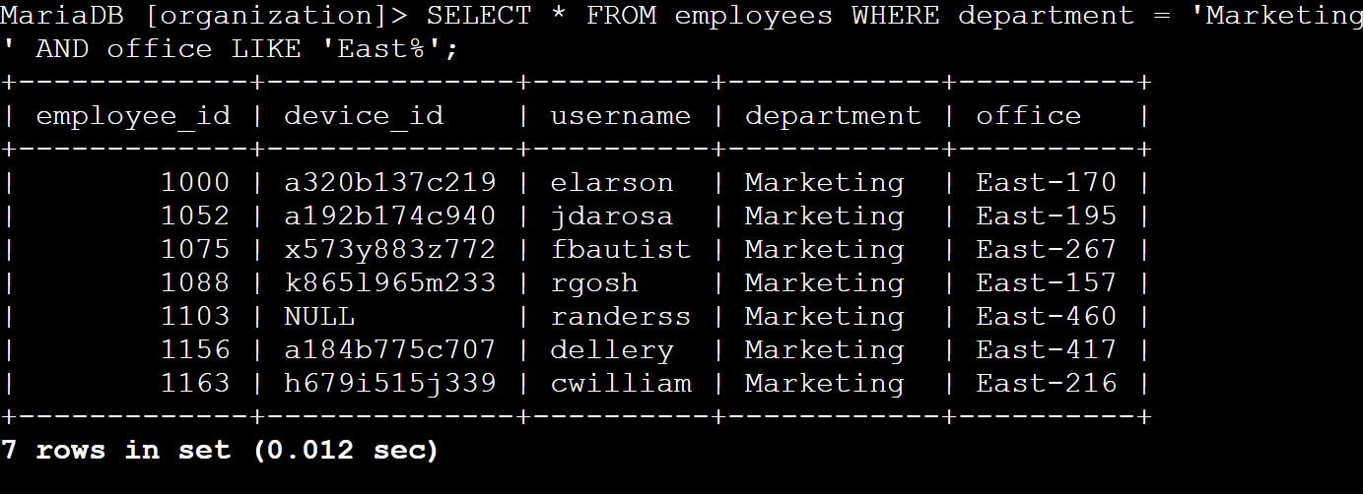

## Retrieve employees in Finance or Sales

SELECT *

FROM employees

WHERE department = ‘Sales’ OR department = ‘Finance’;

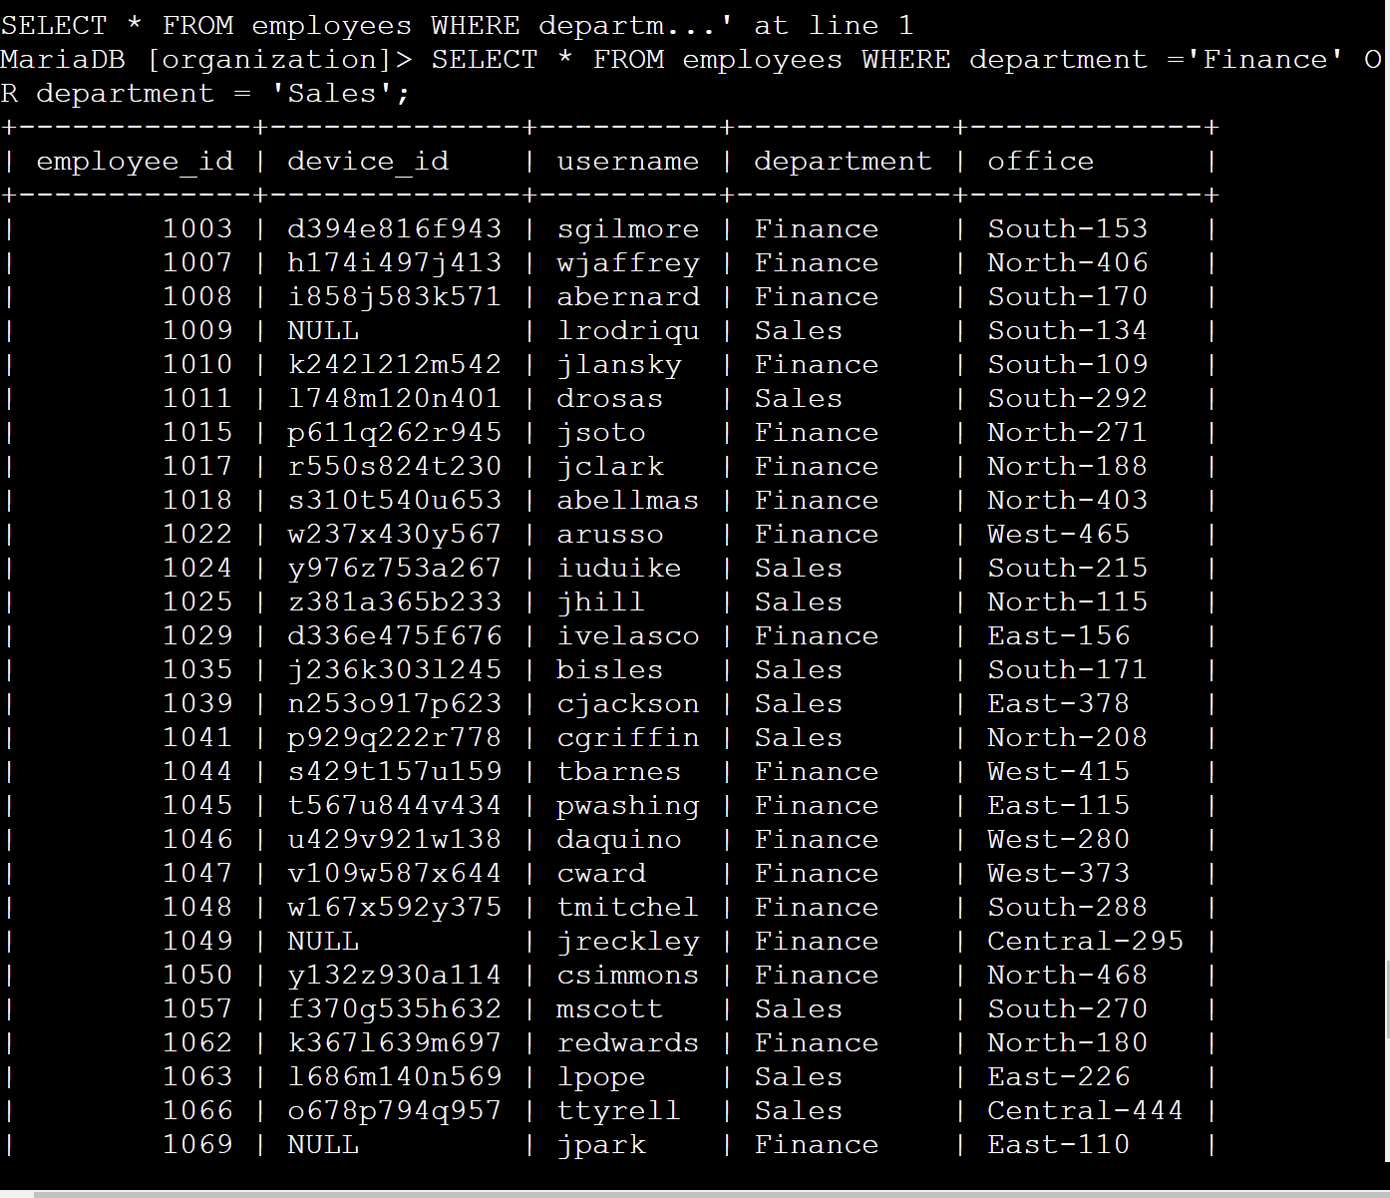

## Retrieve all employees not in IT

SELECT *

FROM employees

WHERE NOT department = ‘Information Technology’;

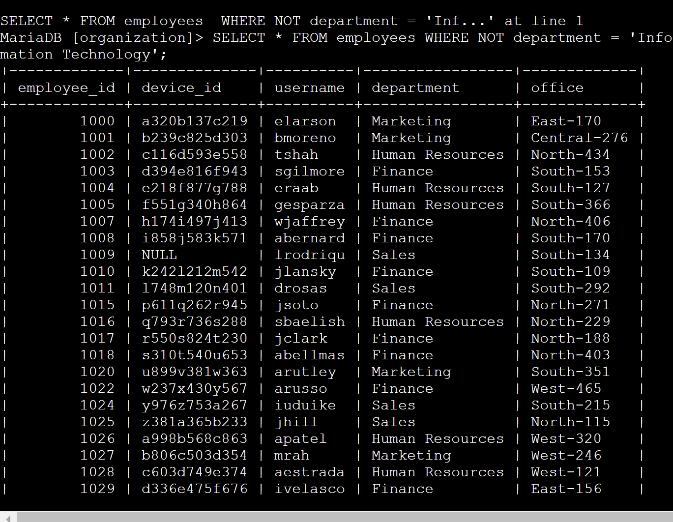

## Summary

This project exercise made me to achieve the following

* run SQL queries to retrieve information from a database and
* apply AND, OR, and NOT operators to filter SQL queries.